**Unity-HoloLens User Manual**

How to build a project in Unity: [1]

1. Install Unity, with these selected components: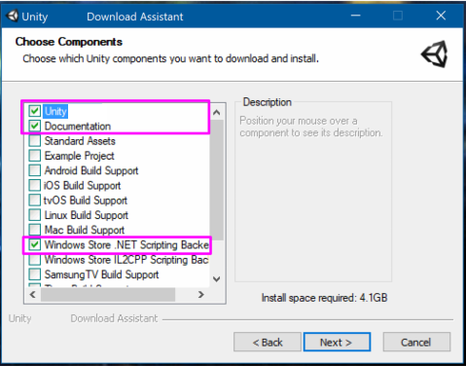
2. Enable Developer Mode for Windows 10 via: Action Center -> All Settings -> Update & Security -> For Developers -> Enable Developer Mode

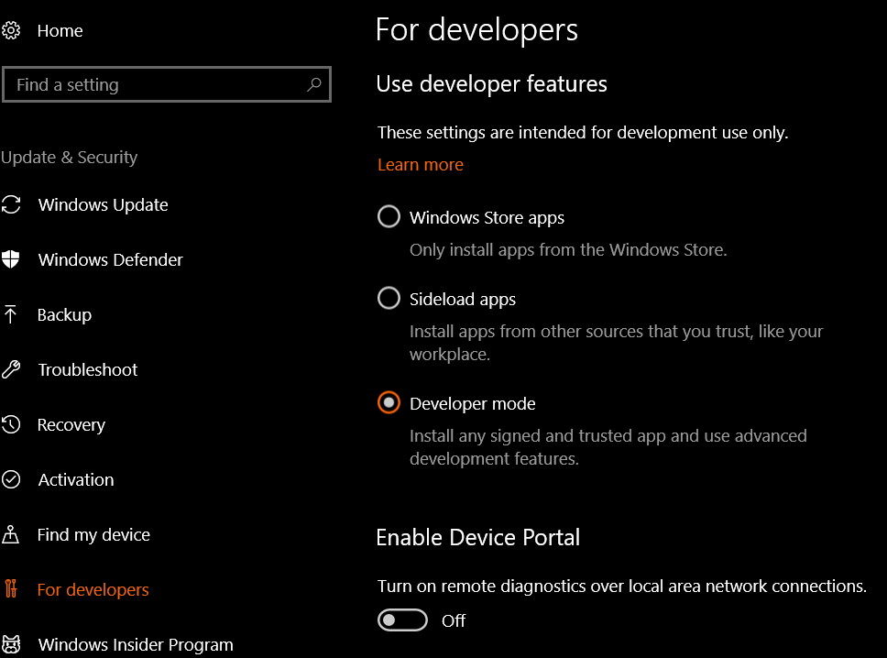

1. Install Visual Studio 2017 along with these components: Windows Universal Platform Development, Windows SDK 10.16299.10, Visual Studio for Unity, msbuild, Nuget Package Manager.

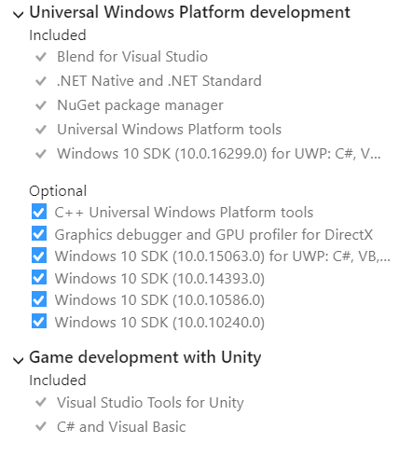

1. Create Project
2. Add HoloToolkit: Download from GitHub, Go to Unity and import by using Assets -> Import Package -> Custom Package… and select HoloToolkit
3. Create a new scene: File -> New Scene
4. Remove the default Main Camera and Directional Light objects
5. Add the HoloLens Camera, Input Manager, and Default Cursor prefabs from the HoloToolKit folder in the assets pane.

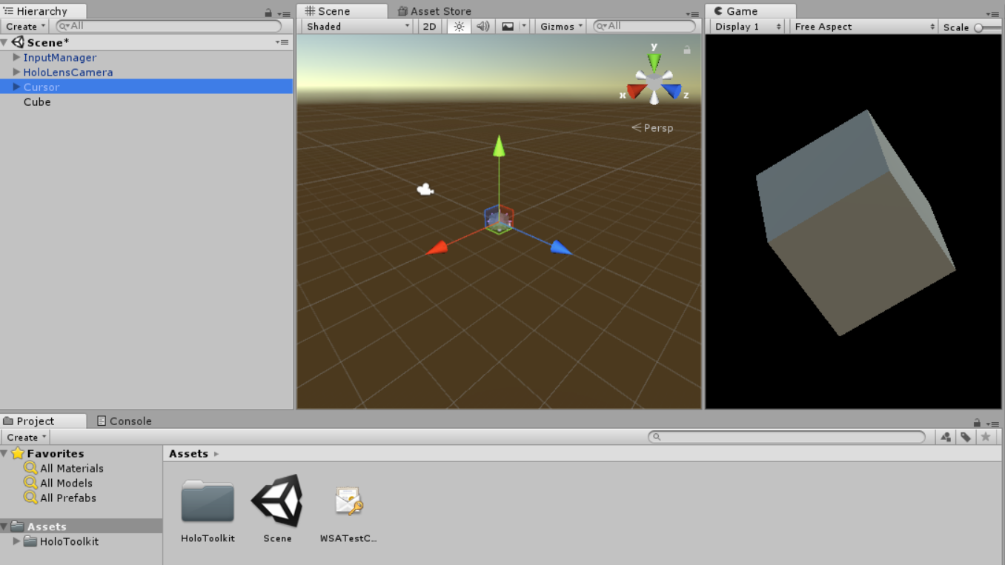

1. Create the object by right clicking in the hierarchy tab and selecting the object in the drop down.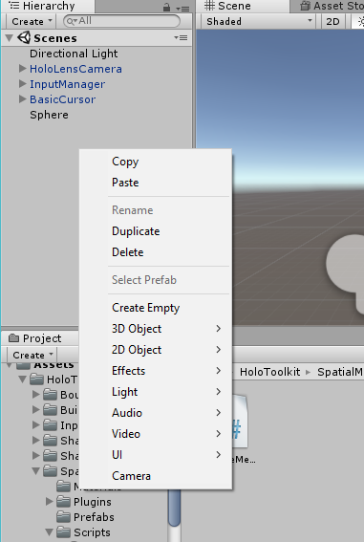

How to deploy to HoloLens through Unity:

1. Create project in Unity
2. Go to File -> Build Settings and configure settings according to below picture.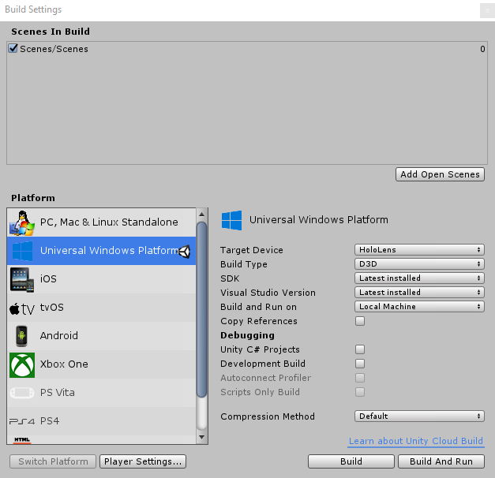
3. Select Universal Windows Platform and click Add Open Scenes and then Build.
4. It will ask you to create a folder, name it whatever you would like.
5. After it is done building go to that folder and open the file with the “.sln” extension, this will take you to visual studio.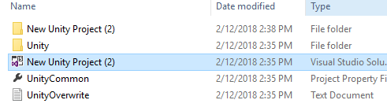
6. Change Debug to Release and ARM to x86 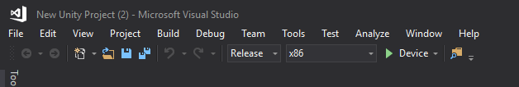
7. Can port to HoloLens through usb or WiFi. When using remote machine the IP address of the HoloLens will be needed, then click the play button. When using a usb to your computer from the HoloLens change the remote machine to device, then click the play button.

Porting with USB: [2]

1. Connect HoloLens to PC with USB and turn on HoloLens.
2. Pair device by going to Settings (in hololens) -> Update -> For developers -> Developer Mode -> enable Device Portal -> click Pair to generate a pairing Pin on the HoloLens.

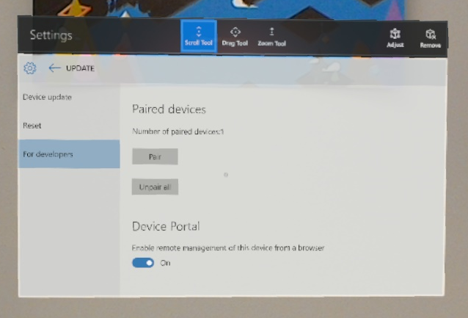

1. Enter pairing pin in Visual Studio when prompted.
2. Go to <http://127.0.0.1:10080>
3. Enter username: [seniordesignsiu@outlook.com](mailto:seniordesignsiu@outlook.com)
4. Enter password: SeniorDesign
5. Go to System -> Apps. Then select the apps you want to start from the Installed apps dropdown menu. Click Start.

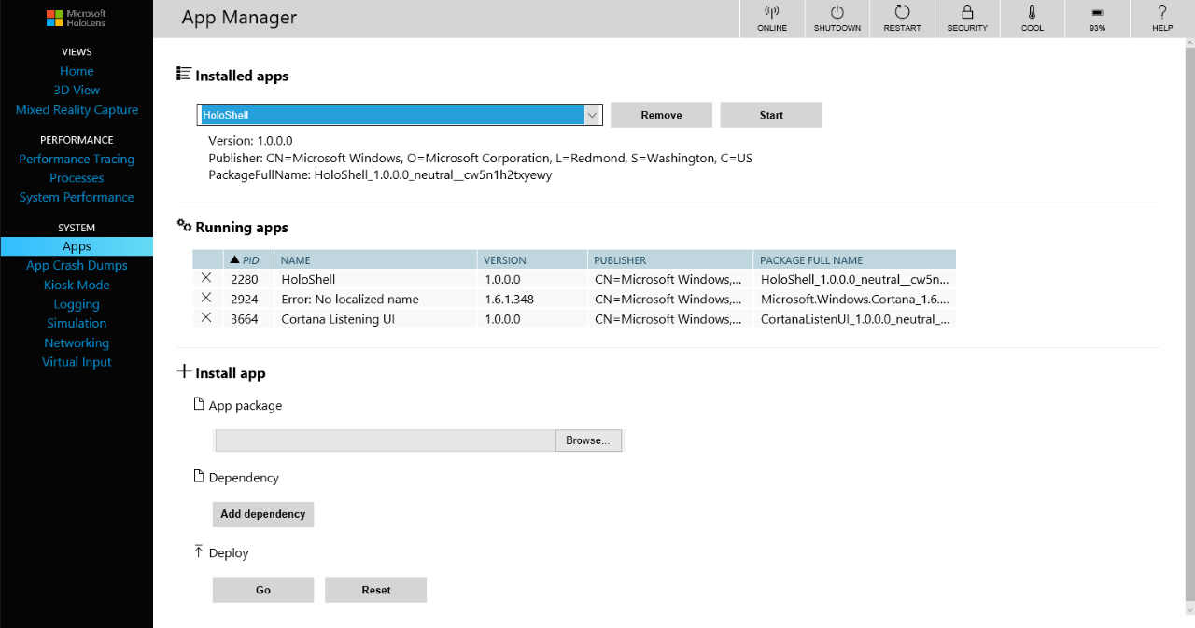

**References:**

|  |  |
| --- | --- |
| [1] | r. A. StephenHodgson, "MixedRealityToolkit-Unity/GettingStarted," Github, 2018. [Online]. Available: https://github.com/Microsoft/MixedRealityToolkit-Unity/blob/master/GettingStarted.md |
| [2] | Microsoft, "Using the Windows Device Portal," Microsoft, [Online]. Available: https://developer.microsoft.com/en-us/windows/mixed-reality/using_the_windows_device_portal#connecting_over_usb |